1.Create a basic aws lambda function.
Go to aws consoleselect aws lambdacreate function.
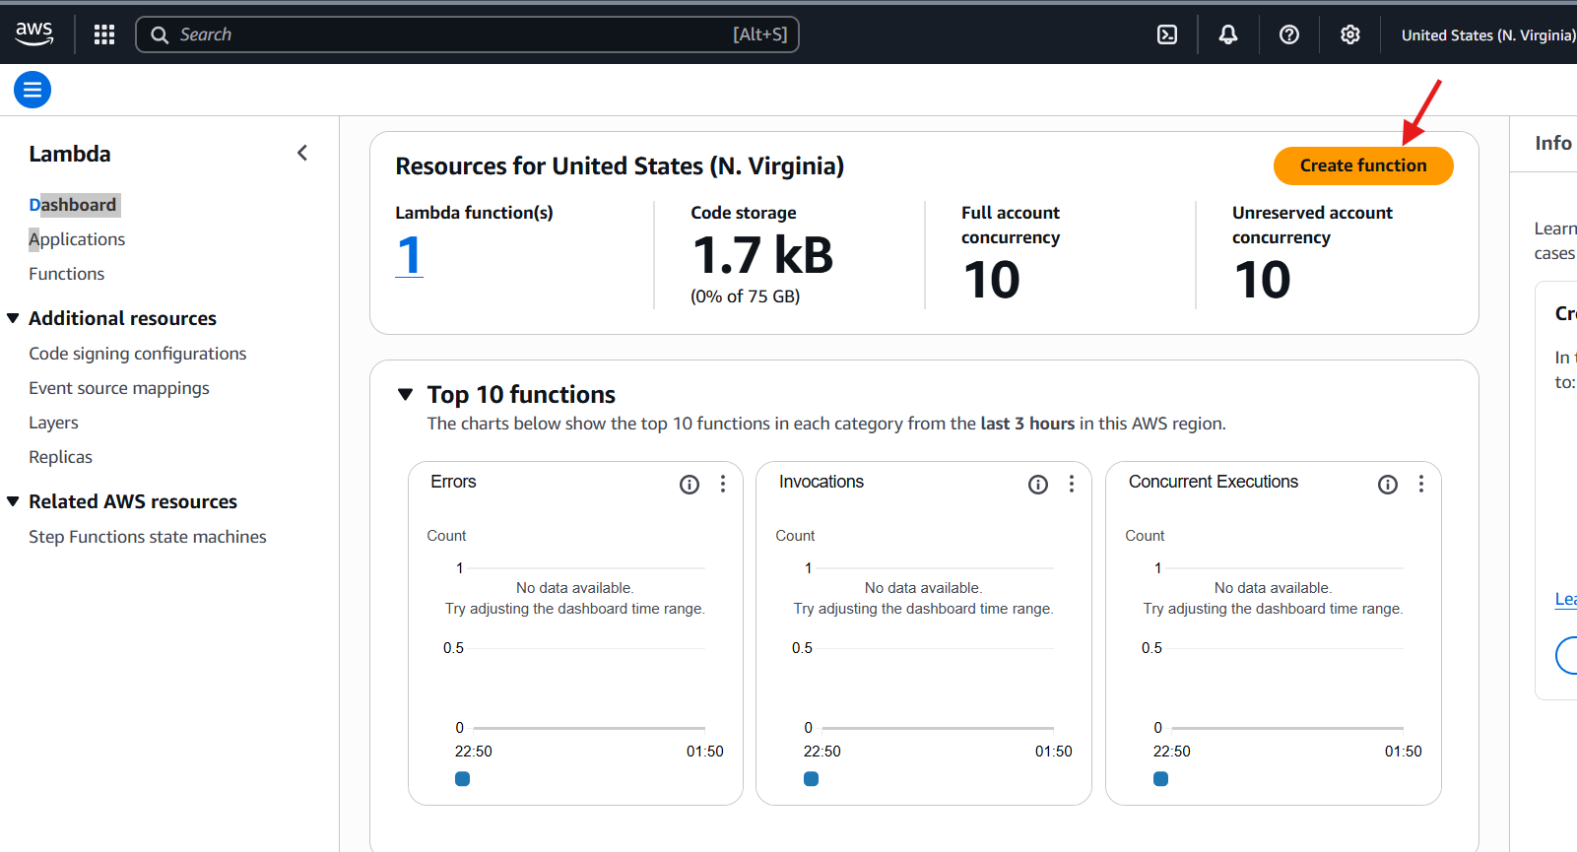
Choose author from scratchselect run timechoose execution rulecreate function.
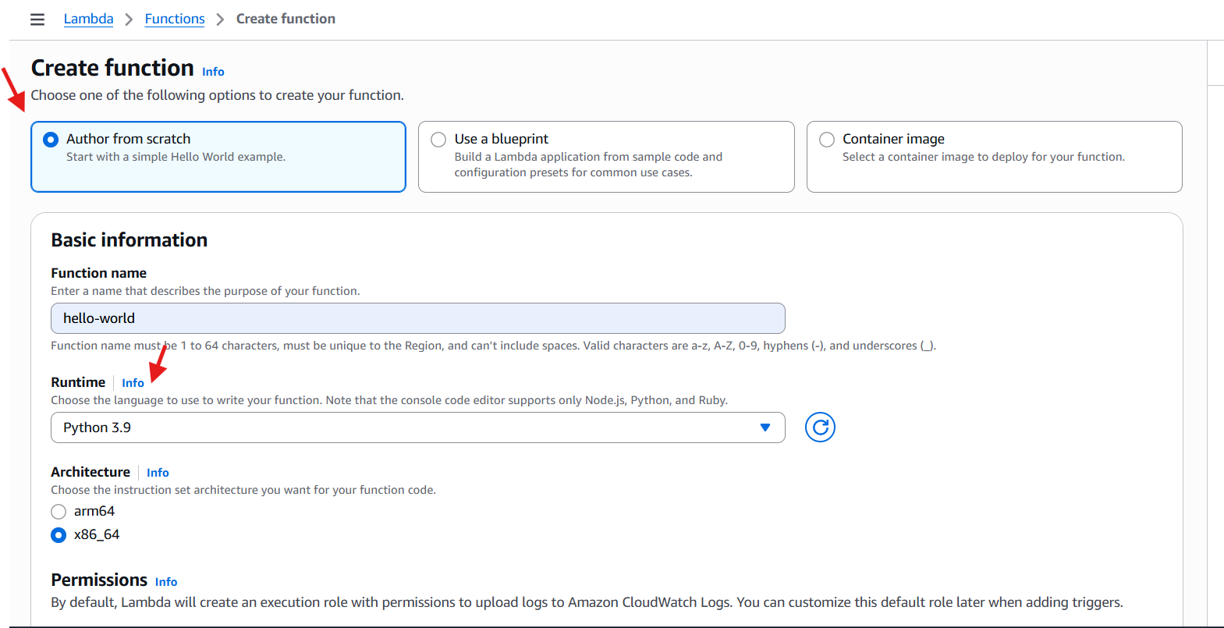
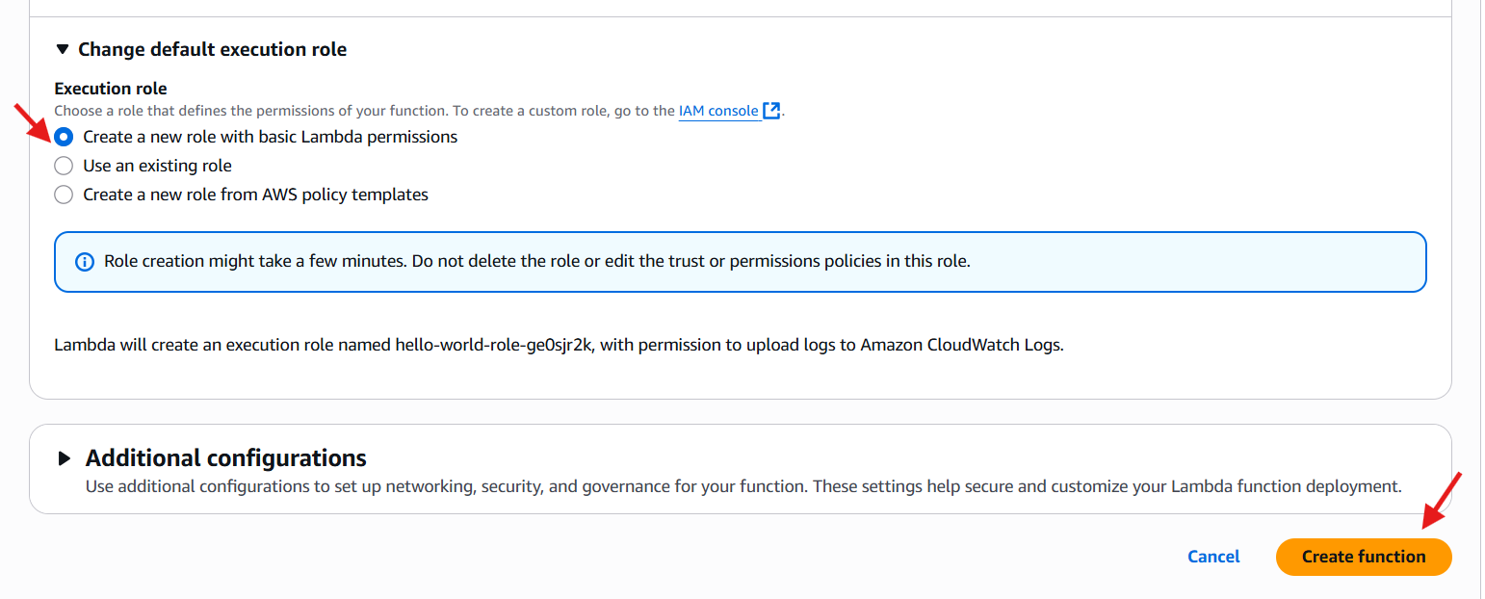
After successfully create function the next tab will be opened.
We can see the editor in only node js and python.
In this tab we create the code,deploy and test.
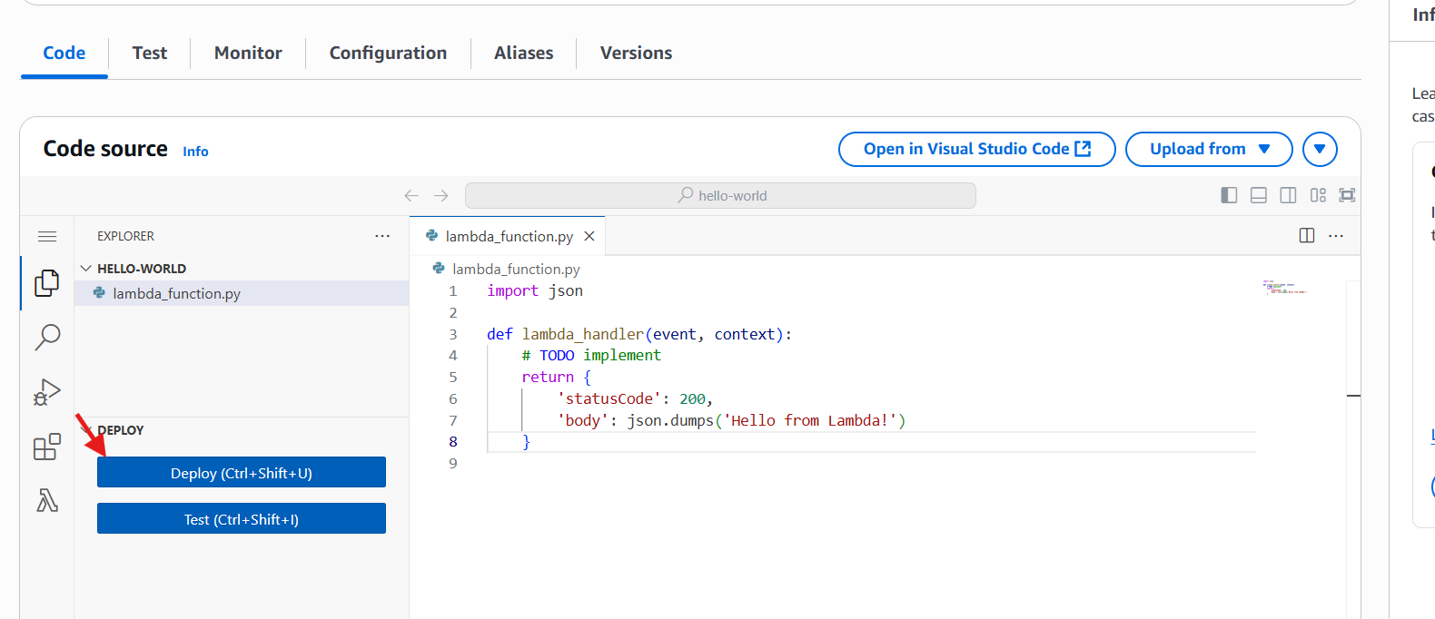
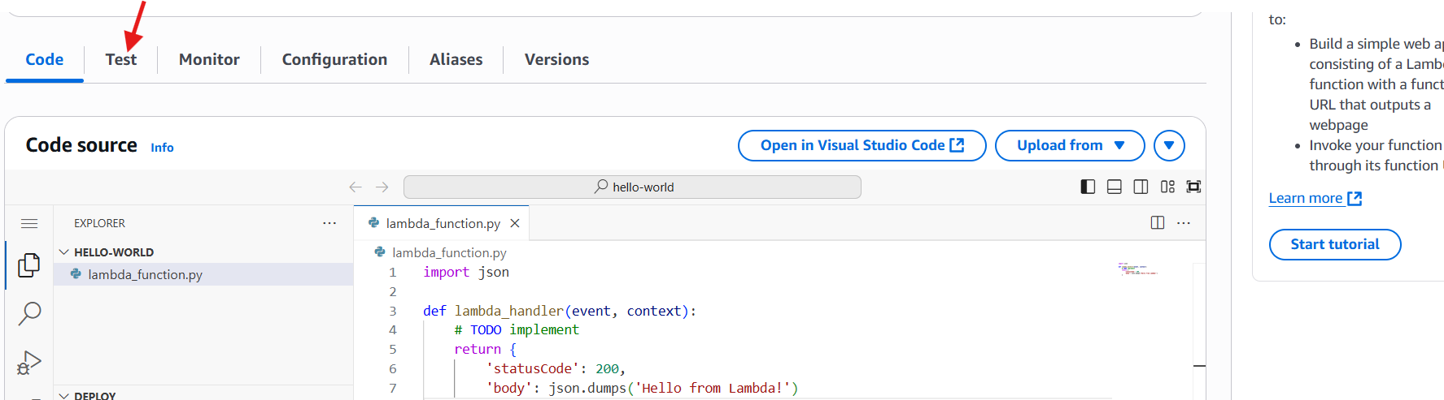
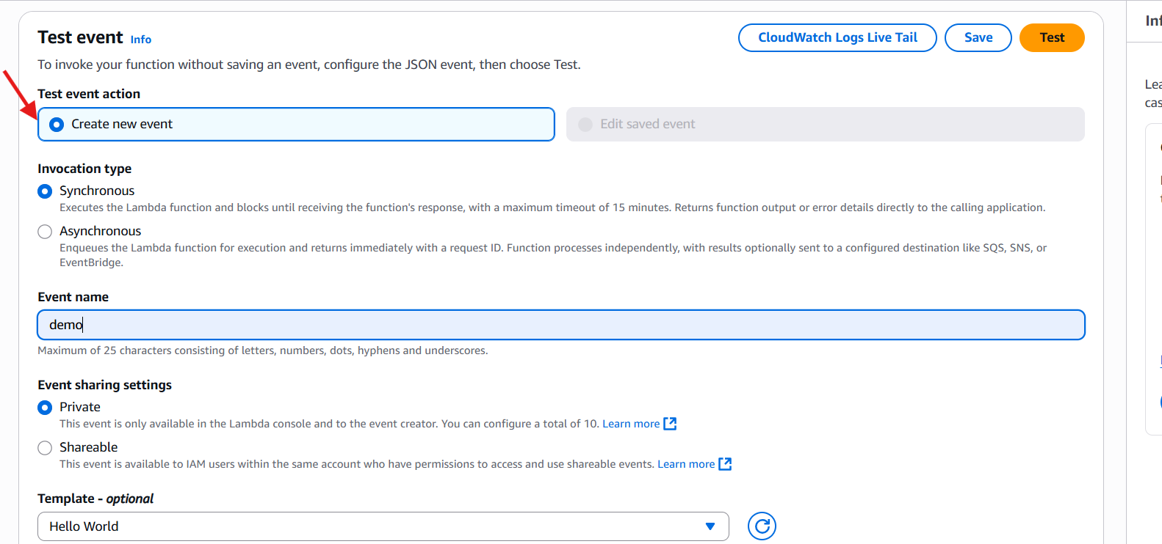
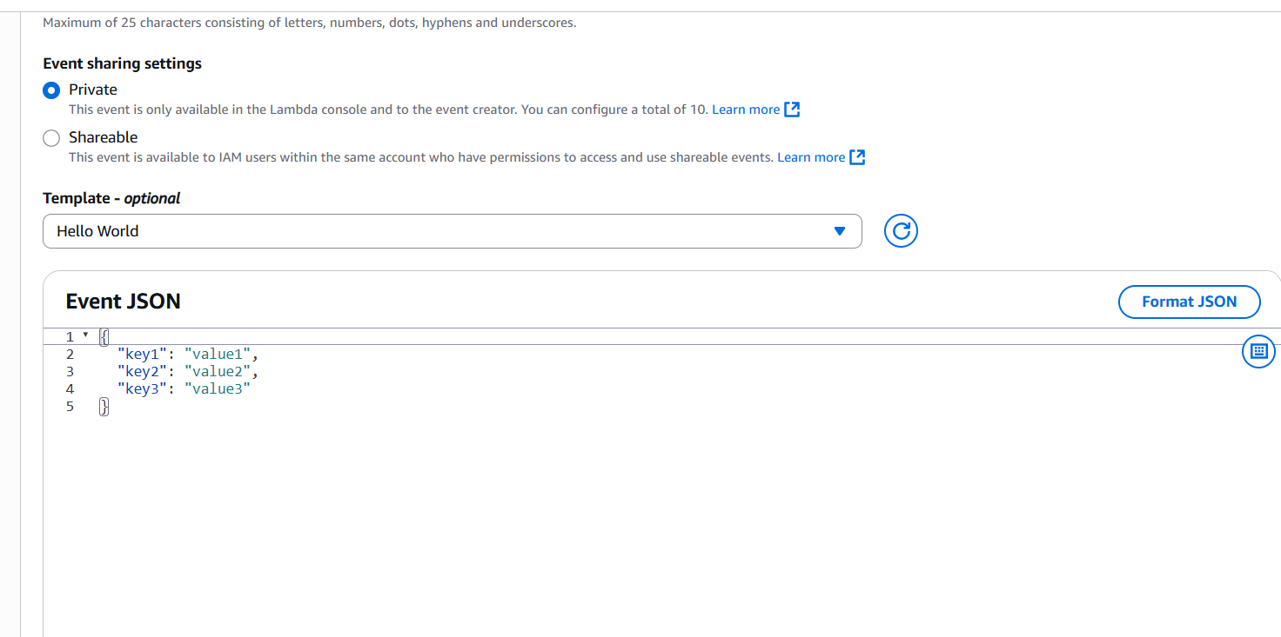
We can see the output in logs.
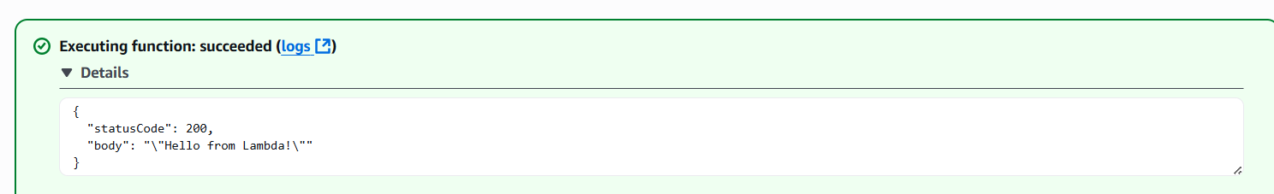
If we have to monitor the logs we have cloud watch logs.
